



Introduction

As of the 1st of June 2011, an online application form has been progressively introduced within the framework of the decentralised Actions of the Youth in Action programme. In 2012, the large majority of National Agencies will require applicants to use such electronic form to submit grant requests under all Actions and sub-Actions covered by the Youth in Action Programme Guide, except European Voluntary Service.

The promoter assuming the role of Coordinator will need to submit the completed online application form on behalf of all the partner promoters. Partners do not need to submit additional applications electronically to their respective NAs. However, they do need to contribute equally to the content of the application. Once the electronic form is submitted, each partner promoter must also send to the Coordinator the original Preliminary Agreement (see below, Section II point 6). This will serve to completing the hard copy of the form to be submitted to the National Agency.

Promoters will be invited to apply online under the following Actions/sub-Actions managed at national level by a National Agency:

- Sub-Action 1.1 Youth Exchanges
- Sub-Action 1.2 Youth Initiatives
- Sub-Action 1.3 Youth Democracy Projects
- Sub-Action 3.1 Youth Exchanges (in cooperation with Neighbouring Partner Countries)
- Sub-Action 3.1 Training and Networking (in cooperation with Neighbouring Partner Countries)
- Sub-Action 4.3 Training and Networking
- Sub-Action 5.1 Meetings with youth people and those responsible for youth policy

The electronic application form is available on the National Agencies websites. These addresses can be found at:

http://ec.europa.eu/youth/orphans/contact-list_en.htm?cs_mid=152

These guidelines aim at:
- providing detailed information on the new application procedure
- illustrating the main features of the online form
- providing information on trouble-shooting

Stages of the application process

The application process is as follows:

- The Coordinator should download and save the electronic application to its own computer.

- The Coordinator should collate information and input from all partners involved and prepare the common Application Form.

- The Coordinator should submit the completed application electronically following the instructions on the electronic application form. Once submitted, the application form cannot be modified.

- After submission, the Coordinator should save the electronic PDF version of the submitted application form.

- The Coordinator must then send the PDF copy of the application form to the partner promoters electronically.

- On receipt of the PDF application form from the Coordinator, each partner should:

- get the part "Preliminary Agreement of the partner" signed by the legal representative

- send by post to the Coordinator (N.B. not to the National Agency) the Preliminary Agreement duly signed. If the time before the expiring of the deadline is running by, the Preliminary Agreement can also be anticipated to the Coordinator by fax provided that it is followed by the original by regular mail.

- on receipt of the Preliminary Agreements by each partner, the Coordinator should prepare the "hard copy package" to be sent in to the National Agency by a given deadline.

IMPORTANT Both electronic and hard copy versions of the form must be submitted to the National Agency by the deadline. We suggest, therefore that the Coordinator starts the initial process in good time, and that the action in 5) above (sending a PDF copy to partner promoters) takes place at least a week before the final submission deadline.

Your hard copy application must be sent to us by recorded delivery and please keep proof of postage in case your application is delayed or gets lost in the post. Without proof of postage, we cannot accept re-submission of lost application forms.

General steps for completing the online application form

You should download the application form from the website of your National Agency and save it to your own computer before starting to fill it in. If you start writing on the application directly, without first saving it on your own computer, the data you have filled in will not be saved and you will have to start again.

Youth in Action online application forms are PDF files and can be filled with Adobe Reader. Adobe Reader is free and available from www.adobe.com. You will need to use version 8.2 or higher of Adobe Reader. You may be required to update your computer’s version of this software. If your computer does not have the necessary version you will receive a warning message when first opening the form. Please do not ignore this message; failure to update your Adobe Reader will lead to the loss of all entered information. Upon saving, closing and reopening the form or when fully completing, validating and submitting, you will lose the form's content and will not be able to email or print the form. If this happens, you will have to start again, as the National Agency has no way of retrieving this lost data. It is recommended, in all cases, to use the latest version of Adobe Reader.

You must always zip/compress the application form when emailing it or copy it to an external form of media storage (flash drive, external hard drive, etc) as this will bypass any form of file-blocking and avoid the file becoming corrupt.

Before you start to fill in this application form, please ensure you have read the Youth in Action Programme Guide available at the website of your National Agency or on the Commission's website at http://ec.europa.eu/youth/youth-in-action-programme/programme-guide_en.htm. Your application will be assessed against the requirements and standards set out in this document.

Filling in the form

This can be done offline, i.e. you do not need to be connected to the internet during this stage.

Different sections of the form need different treatment:

- Compulsory sections have a red border. These sections must be completed. The validation process (described below) will not allow you to submit the form unless this is done.

- Automatic sections have a grey background. These will be filled automatically based on entries you make elsewhere in the form. You cannot enter data into these sections.

- Adding/deleting. If there are tables and fields in the form where multiple entries are possible or blocks/sections that can be repeated, the applicant can add or delete rows or sections by clicking on the buttons   or .

- Calculations The results of numeric calculations and the numbering or rows and repeaters appear automatically in most tables but in other cases, when a button appears, the applicant has to click on this button to obtain the result of the calculations. This case applies to calculations, which can be overridden by the applicant in case (s)he would like to correct the calculated amount (whereas it is allowed).

IMPORTANT Please consider that this e-form may be used to apply for most of the decentralised Actions and sub-Actions of the Youth in Action Programme. Therefore, depending on the choices you make from various drop-down menus within the form, other boxes will appear. Make sure that you choose the appropriate fields in the menus to avoid that your application is considered ineligible (e.g. if you plan to organise a Youth Exchange with Neighbouring Partner Countries you should select "Action 3"/ "sub-Action 3.1 Youth Exchanges" and not "Action 1" – sub-Action 1.1 Youth Exchanges").

You can save part-completed versions of the form at any time and return to it at a later date; If you save the form regularly, you will avoid loosing data.

Validating the form (by clicking on the "Validate” button)

This can be done offline, i.e. you do not need to be connected to the internet during this stage.

The validation will check that all necessary parts of the form have been completed. If there are any incomplete sections, you will be prevented from submitting the form and will be alerted to the first incomplete section identified by the validation process. This process may need to be repeated until all of the incomplete sections have been identified and corrected.

N.B. do not validate each page separately as you go along, as correct validation can only be done at the end when all the compulsory fields have been completed. If you do try to validate each page as you go along, the form will jump to the next mandatory field and you may miss sections that are relevant to your application.

Submitting the form electronically

This stage needs a connected to the internet during this stage.

Pressing the "submit" button will automatically send the completed form to the European Commission’s database. If successful, you will a) receive a "submission confirmation” notification and b) a “Submission ID” will be filled-in automatically in the section "SUBMISSION" of the electronic form.

In case of failure of the submission procedure (e.g. the “Submission ID” doesn’t appear in section SUBMISSION or if a submission error is displayed), as a last resource you can exceptionally create an email attachment version of the form to send to the National Agency.

Printing the form (by clicking on the "Print Form" button or the "print" function in the File menu)

You must print out the submitted version of the form for signature, along with the submission confirmation document.
For a correct print-out of the form it is recommended to select the option “Shrink to Printable Area” in the “Print” window as shown in figure 4 below.
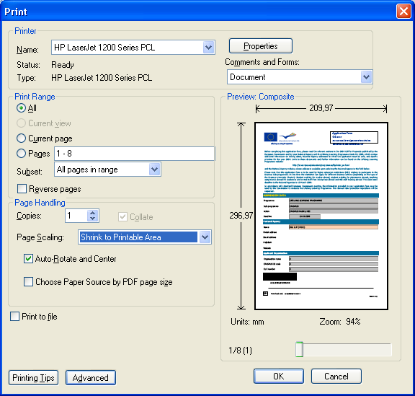

Submitting the form (Hard Copy)

You must send the original of the signed completed form to the National Agency.
To do so, you must:
- print the application form submitted electronically, together with the “submission confirmation” notification (see above)
- replace the Preliminary Agreement sections with the versions signed in original (or faxes) received from the partners
- fill-in manuscript, sign and stamp the relevant sections of the form (this should be done by the person authorised to enter into legally binding commitments on behalf of your organisation/group)
- annex any additional document required (as described in the Part L "Check List " of the form. For example, the daily timetable of the Activity in case of a Youth Exchange)
- send in by post the whole package to their National Agency, by the given deadline

Keep a copy of everything for yourself.

Opening eForms on Mac computer

Mac-computers use the application "Preview" as a default to open pdf-files. Youth in Action application files (pdf) cannot be opened by "Preview", only by Adobe. If "Preview" is set as the default application to open pdf-files, your Mac will not open the Comenius documents, even if you download and install Adobe on your Mac. Adobe should be set as the default (instead of "Preview").
- Procedure 1 (Adobe has not been downloaded on your Mac yet)
Download and install Adobe X 10.0.0 on your Mac. When first opening Adobe you will be asked if you want to set Adobe as the default to open pdf-files: select YES
- Procedure 2 (the latest version of Adobe has already been installed on your Mac, but is not the default application to open pdf-files)
Select any pdf-file anywhere on your computer (just click on it). Go to the 'File' menu and select "Show info " in the submenu "open with" >> select "Adobe Reader" in the same submenu then select: "change all" (i.e. 'use this application to open all files of this type')

Trouble-shooting

Problem | Solution
- The PDF form is not readable in your PC | - An outdated version of Adobe Reader is perhaps installed on your PC. Please go to www.adobe.com and install version 8.2 or higher of Adobe Reader
- The form is "slow"; encoding or saving data in the form takes long time. | - Due to the fact that the form is designed to contain a large amount of data, encoding or saving these data in the form might become a relatively lengthy process, especially in case of projects with a high number of partners. E.g. saving a form containing information about 16 partner promoters may take up to one minute. Please consider this aspect and do not close the programme during this period in order not to loose data.
- You are not able to submit the form | - Please contact your National Agency
- For any other technical or procedural question | - Please contact your National Agency

